 | Autumn Term – Year 5
 | Autumn 1 | Autumn 2
Writing skills focus:
- Write for a range of audiences and purposes (to inform, entertain and persuade)
- Use the correct tense consistently throughout a piece of writing.
- Start sentences in different ways (ed/ing/ly, simile openers, adverbials of time/place, manner)

 | Genre focus  Fiction: Good vs Bad  Non-fiction: Instructions  Poetry: Riddles | Genre focus  Fiction: Fantasy story  Non-fiction: Biography
Core text | Harry Potter and the Philosopher’s stone  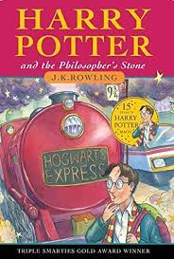 | The Nowhere Emporium  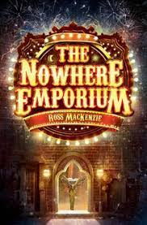  (BOOK NEEDS STARTING IN AUTUMN 1)
Fiction | Good vs evil story – writing a new chapter for the book | Fantasy story
Non-fiction | Instructions – writing spells to follow | BIographies
Poetry | Riddles
Hook ideas

Short burst writing opportunities | Figurative language  Contrasting recounts  Potions  Drama  Job advertisement | Character profile  Note taking  Formal vs informal writing
Texts to enrich learning
Wider curriculum writing opportunities (if apt)
Bredbury 50 things links

 | Spring Term – Year 5
 | Spring 1 | Spring 2
 | Writing skills focus:  - Link ideas within paragraphs (connecting adverbs and adverbials for time, place and how)  - Develop characters through action, description and dialogue  - Use inverted commas and other punctuation accurately to indicate direct speech. | Writing skills focus:  - Link ideas within paragraphs (connecting adverbs and adverbials for time, place and how)  - Add well-chosen detail to interest the reader.
 | Genre focus  Fiction: Suspense story  Non-fiction: Non-Chronological report  Poetry: Creating images | Genre focus  Fiction: Adventure story  Non-fiction: Information text  Poetry:
Core text | 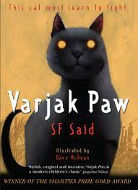  Varjak Paw | Beetle Boy  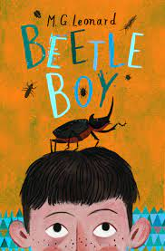
Fiction | Suspense story | Adventure story
Non-fiction | Non-chronological report | Information text
Poetry | Creating images
Hook ideas

Short burst writing opportunities | Setting description  Character description  Speech | Formal letter  Formal vs informal  Change informal to formal  Fact file  Note taking  Setting description  Character description
Texts to enrich learning

Wider curriculum writing opportunities (if apt)
Bredbury 50 things links

 | Summer Term – Year 5
 | Summer 1 | Summer 2
Writing skills focus:
- Use settings to create atmosphere and indicate a change
- Manage shifts in time and place effectively to guide the reader through the text.
- Use the perfect of verbs to mark relationships of time and cause.
- Choose words for deliberate effect.
 | Genre focus  Fiction: Stories from other cultures  Non-fiction: Newspaper report  Poetry: | Genre focus  Fiction: Real-life stories  Non-fiction: Explore a range of short burst opps  Poetry: Blackout poetry, list poem
Core text | The 1000 year old boy  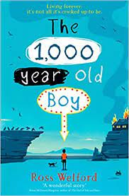 | Survivors (literacy shed)
Fiction | Stories from another culture | Real life stories
Non-fiction | Newspaper report | See below
Poetry
Hook ideas

Short burst writing opportunities | Diaries  Letters  Description  Exploring characters  Then and now comparisons  Police report | Newspaper reports  Information texts  Monologue  Profile page
Texts to enrich learning

Wider curriculum writing opportunities (if apt)
Bredbury 50 things links

